**Ideation Phase**

**Brainstorm & Idea Prioritization Template**

|  |  |
| --- | --- |
| Date | 19 September 2023 |
| Team ID | 652E2C7645EE5CDA43F44AEEE4D06295 |
| Project Name | Competitive Analysis of Leading Travel Aggregators |
| Maximum Marks | 4 Marks |

**Brainstorm & Idea Prioritization Template:**

Reference: <https://www.mural.co/templates/empathy-map-canvas>

**Step-1: Team Gathering, Collaboration and Select the Problem Statement**

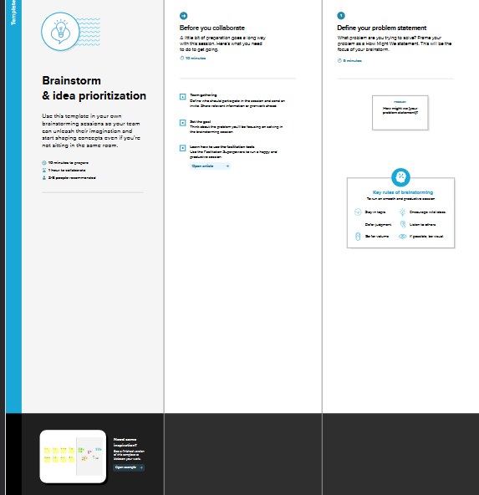

**Step-2: Brainstorm, Idea Listing and Grouping**

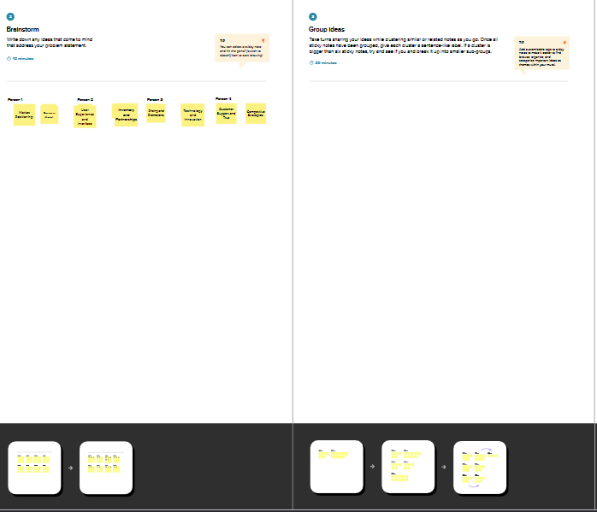

**Step-3: Idea Prioritization**

